JULY 2023
IMMANUEL EVANGELICAL LUTHERAN CHURCH
Connecting people with God and
with other people to make a difference!
14100 WORTHINGTON RD.
PHILADELPHIA, PA 19116

Phone: 215-464-1540
www.ImmanuelPhilly.org
Immanuel’s E-news is sent to inboxes every Friday afternoon.

Please make sure to check your email for all the latest news!

Immanuel Newsletter
GOD’S WORK – OUR HANDS

Table of Contents

CONNECTING WITH GOD
From Pastor Hahn Page 2
Bilingual Column Page 3

CONNECTING WITH OTHERS
Movie Under the Stars Page 4
Picnic Page 4
In Christian Sympathy Page 4
Graduates Page 5

MAKING A DIFFERENCE
Senior Resource Event Page 6
July Cereal Drive Page 7
Thank You Page 7
World Refugee Day Gifts Page 7
Calendar Page 8

See Pages 2 and 8 for details!

CONNECTING WITH GOD

FROM PASTOR HAHN:

My dear Immanuel church family:

Would you like to know what the future of our church family looks like? If so, then take a quick look in the mirror! You are the future of the Immanuel church family!

Sure, God may send new people to us at some point in the future. Our outreach events to the surrounding community may move a neighbor to try one of our worship services for the first time. Your friendly welcome to a first-time guest and a personal invitation to him or her to join you for the fellowship hour after worship may even convince them to return for another visit. Our compassion for hungry people in our area and our special gifts for refugees across the world may convince someone that we are a congregation worth joining. But these people are not (yet) the future of Immanuel. You are the future of Immanuel! Now!

Your prayers now, your engagement now, your generosity now, your encouragement and support of congregational leaders now—all the positive and supportive impact you can provide—all that is part of Immanuel’s future. Because the future starts now!

During the month of June, we saw with the Senior Resource Event and the Congregational Picnic what awesome things can happen when members and friends of Immanuel combine efforts, and offer time, talent, and treasure in a positive and generous way.

Page 2

I am reminded here of what Dr. David Rogne said of “character”: “People of character are people who want to make a contribution. They see that there are problems in life, and rather than retreating to
personal comfort and non-involvement, they seek to be of use.” Fortunately, our church family is blessed with an abundance of people of character.

One more thing. The cousin of character, someone said (I forgot who said it) is “attitude.” And, as has been pointed out, “attitude is like a paintbrush; it colors every situation.”

That insight, “attitude is like a paintbrush; it colors every situation” is the starting point for our special summer series. Each Sunday we (Dr. Jim Clements and I) will address Christian attitudes centered on the love and hope of Jesus Christ that give us strength for the living of these days.

God’s Peace, Pastor Hahn

July 2, 9:30 AM + 11:00 AM + 6:30 PM (all with Holy Communion): “Introduction to the Series”

July 9, 10:15 AM: “Open-Mindedness”

July 16, 10:15 AM: “Humility”

July 23, 9:30 AM + 11:00 AM + 6:30 PM (all with Holy Communion): “Gratitude”

July 30, 10:15 AM: “Determination & Perseverance“

Aktion "Beim Namen nennen"

Was haben die Städte Basel, Berlin, Bern, Braunschweig, Chur, Dortmund, Essen, Frankfurt, Genf, Kehl, Lausanne, Luzern, Neuchâtel, Offenburg, St.Gallen, Thun, und Zürich gemeinsam?

Dort passierte Mitte Juni in verschiedenen Kirchen
etwas Außergewöhnliches, das insgesamt 32 Stunden dauerte.
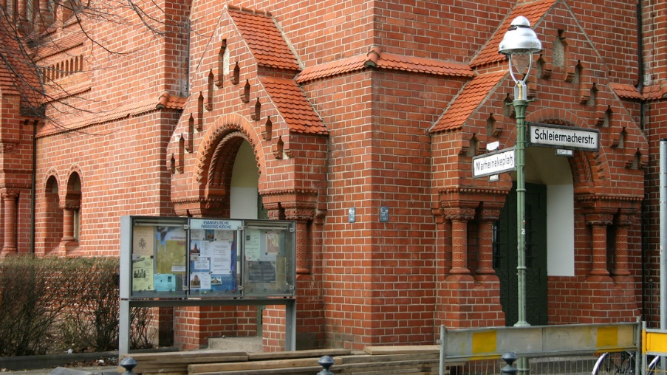
In Gedenkveranstaltungen wurden die Namen von mehr als 51.000 gestorbenen Flüchtlingen, die seit 1993 auf der Flucht nach Europa ums Leben gekommen sind, sowie deren Todesumstände vorgelesen. In Berlin, zum Beispiel, wurden die Namen der Toten zudem auf Stoffstreifen vor und in der Kirche aufgehängt.
In Berlin fand die Aktion “Beim Namen nennen“ in der Passionskirche in Kreuzberg statt. Anlass war der Weltflüchtlingstag am 20. Juni

Die Ratsvorsitzende der Ev. Kirche Deutschland und Präses der Ev. Kirche von Westfalen, Annette Kurschus sagte in ihrem Grußwort: "Teuflisch ist es, dass abertausende Menschen, die bei ihrer Flucht umkommen, namenlos bleiben. Sie werden an Grenzzäunen getötet und ertrinken im Mittelmeer. … Jeder Name, der gelesen wird, ist ein Protest gegen ihren bitteren Tod.“

Bischof Stäblein, der auch Flüchtlingsbeauftragter der Evangelischen Kirche in Deutschland ist, sagte:
"Noch immer ertrinken Menschen auf der Flucht im Mittelmeer, weil sie nicht gerettet werden, weil sie nicht an Land gelassen werden. Diese Menschen haben einen Namen. Sie alle haben ihre ureigene Geschichte, Familien und Freunde, die sie lieben. An diese Menschen und ihre Schicksale, an ihre Hoffnungen auf ein besseres Leben und ihre Träume müsse erinnert werden.“

Mehr bei evangelisch.de
Page 3
“Say their Names“

What do the cities Basle, Berlin, Bern, Braunschweig, Chur, Dortmund, Essen, Frankfurt, Genf, Kehl, Lausanne, Luzern, Neuchâtel, Offenburg, St.Gallen, Thun, and Zurich have in common?

Something very special happened in those cities in the middle of June, and this “very special thing” lasted for 32 hours.

It took 32 hours to read out loud the names of more than 51,000 refugees who have died since 1993 while trying to flee to safety in Europe. In Berlin, for example, their names were also written on strips of cloth.

Annette Kurschus, the president of the Protestant Church in Germany and the bishop of the Protestant Church of Westphalia, commented thusly: “It is diabolical that thousands of people who die on their journeys to safety remain nameless. They are killed at border fences or drown in the Mediterranean…. Each name read out loud is a protest statement against their horrible deaths.”

Bishop Stäblein who leads the refugee ministry of the EKD stated: “Human beings still drown in the Mediterranean while trying to reach safety because no one comes to their rescue, because they are not allowed ashore. Each of them has a name. Each of them has a unique story as well as family and friends who love them. We must remember these human beings, their fate, and their hopes and dreams for a better life.”

More at evangelisch.de

CONNECTING WITH OTHERS
Unter ihnen waren auch Alexander Pröhl und Carol Mertins mit ihrer zwei-jährigen Tochter Emma-Rose. Sie seien von der besonderen Atmosphäre und der tradi-tionellen Art der Taufe begeistert, berichtete Papa Pröhl. Eigentlich habe das Kind schon gleich nach der Geburt getauft werden sollen, doch Corona habe der Familie einen Strich durch die

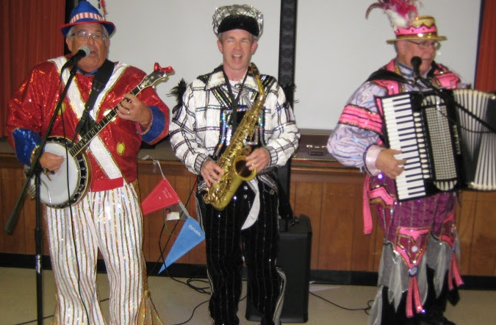
Guests enjoyed plentiful food of many varieties, caught up with old friends and made new ones, and were treated to a special concert by Philadelphia “Mummers.”
A big “thank you” to everyone who helped make the Congregational Picnic on June 11 such a fun event.
In Christian Sympathy
We extend our Christian Sympathy to the Sears and Scheidt families who are mourning the loss of Sally Sears’ niece. Please keep these families in your prayers.
We extend our Christian Sympathy to the family and friends of Anna Kohut, who joined The Church Triumphant on June 4. Funeral services were held on June 19. Thank you for keeping Anna’s family and friends in your prayers.
Page 4
Movie Under the Stars

Friday, July 21

Details coming soon!
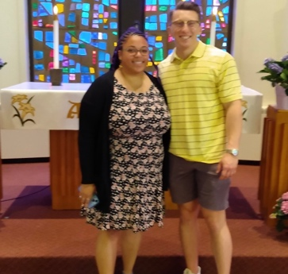
Graduation Sunday

On June 25, we celebrated the members and friends in our congregation who are graduating this year. Congratulations to our graduates!

Hayden (grandson of Jim Clements) graduated from Perkiomen Valley High School and will be attending the University of West Virginia.

Matthew (grandson of Theo and Rosi Sawadski) graduated from George Washington University Law School. He was offered a position at a law firm in New York City.

Alexander graduated from Penn State University with a Master's degree in International Affairs and concentrations in International Security Studies and Middle East Studies, and a Bachelor's Degree in Political Science with minors in German and Business.

Alexis (granddaughter of Veronika Pohl) graduated with a Doctorate in Pharmacy from Jefferson University. Her immediate plans are to take a long-deserved vacation to recharge from all the studying.

Sierra finished her MBA, Master of Business Administration, at Cedar Crest College. In the future she wants to continue working in Higher Education. She is currently the events and communications coordinator in Cedar Crest's Admissions Office.

Wilhelmina (granddaughter of Jim Clements) graduated from South Hunterdon Regional High School and will be attending the University of South Carolina.

Melissa (daughter of Melissa DeVaughn) received a BA in Nursing with honors from Holy Family University. She is exploring options in her field.

Samantha (granddaughter of Bob and Janice Murset) graduated from Hatboro-Horsham high school. She will be attending the University of Delaware majoring in environmental engineering.

Ashley (granddaughter of Joan and Ted Schmidt) graduated from University of South Carolina and will attend Grad School at Anderson University in the field of Physical Therapy.

Grace (granddaughter of Jim Clements) received certification from the University of Penn School of Veterinary Science and will be working at its veterinary hospital.

Ryan (grandson of Jim Clements) graduated from Roanoke College (ELCA) West Virginia and will be entering the Peace Corps stationed in Senegal.

We apologize for any inadvertent oversights or omissions. Please forward your corrections or updates to the church office: (215) 464-1540 or office@ImmanuelPhilly.org.
They will be published in the August newsletter.

Page 5
MAKING A DIFFERENCE

Making A Difference in the Life of Seniors

Q: What do you get when you combine six speakers, 18 individuals from the community, 26 members from the Immanuel congregation, and two awesome ministry teams (Member Care and Evangelism)?

A: You get a successful Senior Resource Event!

Although a free lunch (courtesy of Thrivent Financial) was enjoyed by all, the real “meat” of the event was a buffet of helpful information for seniors about (1) fire safety, (2) protection against telephone- and internet-based scams (financial and romantic), (3) local and printed resources specifically for seniors, and (4) advanced funeral planning. A big “thank you” to all who helped makes this event so successful and to all guests!

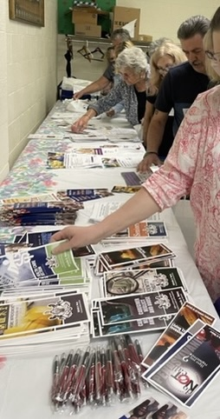
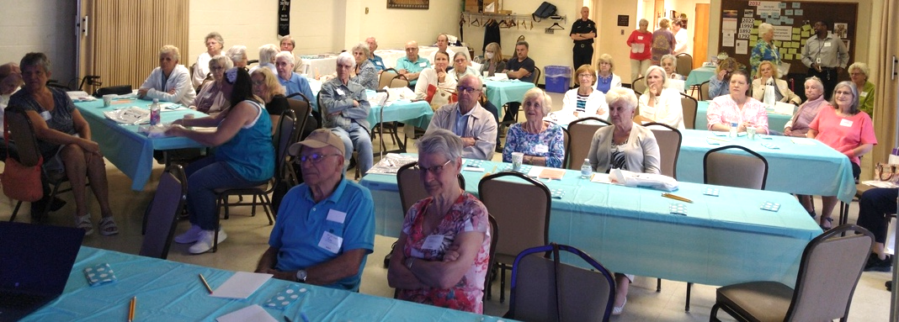
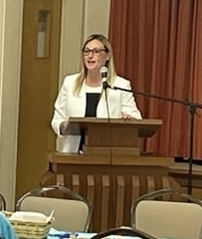
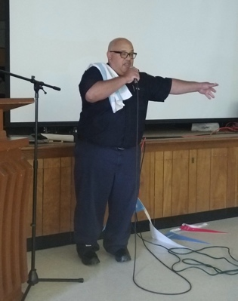
Senior Resource Event
June 8, 2023
Page 6
Will you help make a difference in the lives of hungry
and food-insecure children right here in our community?

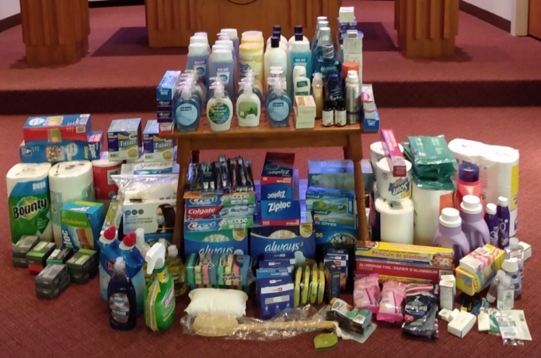
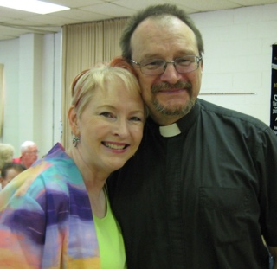
Page 7
Top 10 Most Popular Cereals
(according to Google searches)

- Rice Krispies
- Cheerios
- Chex
- Special K
- Lucky Charms
- Cinnamon Toast Crunch
- Fruit Loops
- Cap’n Crunch
- Frosted Flakes
- Honey Nut Cheerios

Note: Many stores have store brands that have similar tastes and flavors but are less expensive.

During the month of July, our donation emphasis is
Boxes of Cereal.

Last year, we set a goal of 200 boxes of cereal being donated in July. The members and friends of Immanuel rose to the challenge and donated 224 boxes!

This year, we want to challenge ourselves further. Will you help us reach our goal of donating 250 boxes of cereal for the food bank? We have five Sundays in July to make it happen!
Thank you to everyone who gave a special offering in observance of World Refugee Day (June 20). The initial gifts on June 18 totaled $2,150. This amount (and gifts that may still be given) will be sent to Lutheran Immigration and Refugee Service (LIRS) where it will be doubled by a special matching gift from a Lutheran donor.
From Pastor Hahn:
"Thank you for the many cards, calls, emails, and texts with congratulations and good wishes for my birthday. I am very grateful and appreciate your care and concern."
Thank you to everyone
who donated in May to our
Month of Home Essentials!

JULY 2023
Sunday | Monday | Tuesday | Wednesday | Thursday | Friday | Saturday
Summer Worship at Immanuel:  The theme for this summer is “Attitude is Your Paintbrush - It Colors Every Situation.”  Each Sunday we will address Christian attitudes centered on the love and hope of Jesus Christ that give us strength for the living of these days. |  |  |  |  |  | 1
2  Introduction to the Series  9:30 AM English Service  11:00 AM German Service  12:30 PM Council Retreat  6:30 PM English Service  All services with Holy Communion | 3 | 4  Independence Day  Church office closed. | 5 | 6 | 7 | 8
9  Open-Mindedness  10:15 AM Combined Service | 10 | 11  1:30 PM  Member Care Team  7:00 PM Evangelism Team | 12 | 13 | 14 | 15
16  Humility  10:15 AM Combined Service | 17 | 18 | 19 | 20  Newsletter Deadline | 21  Movie Under the Stars | 22
23  Gratitude  9:30 AM English Service  11:00 AM German Service  6:30 PM English Service  All services with Holy Communion | 24 | 25  7:00 PM  Finance Team | 26 | 27  7:00 PM  Congregation Council | 28 | 29
30  Determination and Perseverance  10:15 AM Combined Service | 31
Page 8
Page 8

